Bezannes (France), 4th of May 2026
MyEasyFarm partners with Geocledian for the European Space Agency (ESA) Information Factory Climate Smart Agriculture project
MyEasyFarm, a leading regenerative AgTech startup and recently B Corp™ certified , is proud to announce its collaboration with Geocledian for the "ESA Information Factory: Climate Smart Agriculture" project. The ESA Information Factory is a digital ecosystem designed to make Earth Observation (EO) data more accessible and useful for real-world applications, such as sustainable farming.
In the context of agriculture, this "Factory" acts as a bridge between complex raw satellite data and practical tools. It empowers the industry to adopt Climate Smart practices—such as optimizing water usage, monitoring soil health, and predicting crop yields—by providing the digital "machinery" needed to turn data into actionable intelligence.
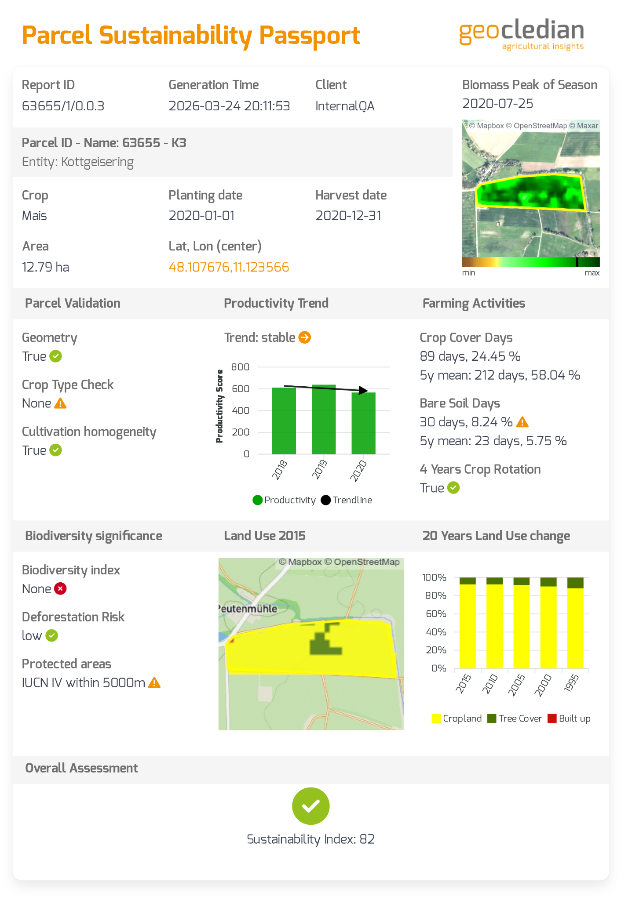
This strategic collaboration, which runs through the end of 2027, marks a major milestone in making advanced satellite insights actionable for large-scale sustainable farming.
A Deepening Partnership with Geocledian
Through this project, MyEasyFarm is stepping up as a System Integrator for the European Space Agency (ESA). This role is centered on a deep integration with Geocledian, a German-based expert in agricultural remote sensing. MyEasyFarm will integrate Geocledian’s advanced remote sensing Key Performance Indicators (KPIs) directly into its SaaS platform. The objective is twofold: first, to challenge and validate the robustness of these KPIs in diverse field conditions, and second, to provide MyEasyFarm users with even deeper, automated insights.
By combining Geocledian's high-precision data with MyEasyFarm's Measure, Monitor, Report, Verify (MMRV) capabilities, the partnership bridges the gap between sophisticated space data and practical regenerative agriculture.

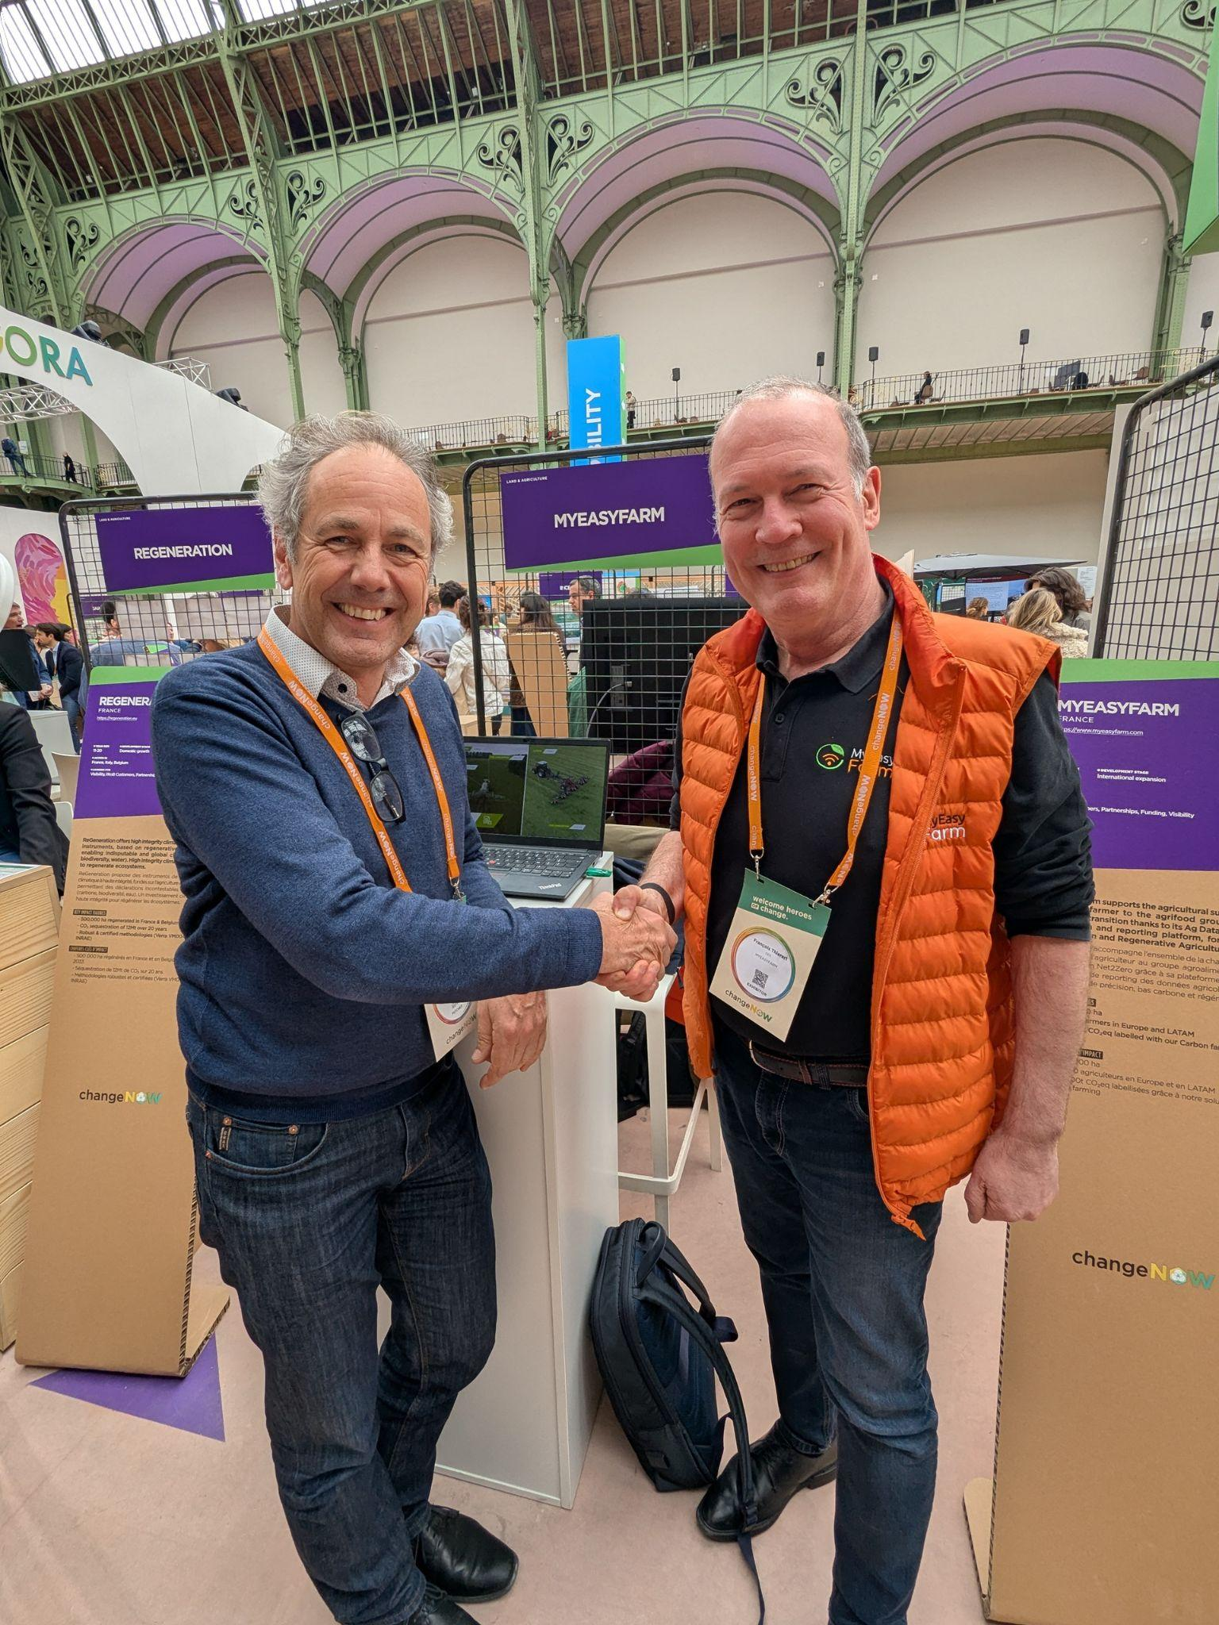
Photo: Stefan Scherer, CEO Geocledian & François Thierart, CEO MyEasyFarm
Powering Global Regenerative Programs
This technical synergy will directly power the regenerative agriculture initiatives of major industry stakeholders.
"Our mission has always been to drive measurable improvements in soil health and carbon sequestration through reliable data," said François Thierart, CEO of MyEasyFarm. "Working closely with Geocledian on this ESA project allows us to push the boundaries of what AgriTech can achieve, turning complex satellite signals into actionable decisions for farmers and food companies alike".
Stefan Scherer, CEO of Geocledian, added: "Combining Geocledian’s precise remote sensing capabilities with MyEasyFarm’s robust MMRV platform creates a powerful engine for Climate Smart Agriculture. This partnership allows us to deliver verified, field-level data right into end-user systems, that truly supports the transition to regenerative farming. We expect to make the cost sensitive MRV process more efficient, reliable and help to increase the value of carbon credits issued. We are proud to contribute our expertise to this ESA initiative and help scale carbon farming solutions across Europe."
Committed to a Sustainable Future
This collaboration reinforces MyEasyFarm’s status as a mission-driven company (société à mission) and its B Corp™ Certification, obtained in March 2026. By using data as a "force for good," MyEasyFarm continues to lead the agroecological transition, supporting global standards such as SBTI and CSRD.

For more information on this partnership and MyEasyFarm's solutions, visit www.myeasyfarm.com.

About MyEasyFarm :

At MyEasyFarm, we’re Ag Data experts. We leverage satellite, agricultural machinery, soil, weather, and virtually any available Ag data in our SaaS collaborative platform. We empower the entire agrifood supply chain—from farmers to food companies—to MMRV (Measure, Monitor, Report and Verify) the shifts in farming practices.
We generate reliable and verifiable KPIs to help Corporates match their Sustainable commitments (SBTI, CSRD, …) and connect farmers to financial incentives like Carbon Credits and Regenerative Agriculture Corporate premiums.
As Kelvin said, “You can only manage what you measure”—our mission is to drive measurable improvements in CO₂ emissions, soil health, and biodiversity, advancing regenerative agriculture for a more resilient future.
MyEasyFarm, B Corp™ certified since March 2026, is based at VillagebyCA Reims and has offices in Italy, the Netherlands, Germany and Brazil. The MyEasyFarm team is made up of 25 people from engineering schools in Agriculture/Agronomy and Computer Science. MyEasyFarm is part of many associations in the AgTech field (La Ferme Digitale, Pôle de compétitivité B4C, Terrasolis, 4pour1000, ...) MyEasyFarm is supported by BPI, Business France and the Grand-Est region and is accelerated by Scal'Enov, HECTAR and is in the EIT Food RisingStar programme.
Follow us: Linkedin - Twitter - Facebook - Instagram - Youtube

About Geocledian:

At Geocledian, we are an experienced geodata analytics company passionate about remote sensing, AI, and Climate Smart Agriculture (CSA). We specialize in transforming complex satellite data into actionable insights for sustainable farming, production monitoring, and EUDR compliance. As leaders in the field, we develop innovative data analysis services that make agricultural processes more transparent and efficient.
Our proprietary AgKnowledge API platform serves as the backbone for scalable, custom-fit solutions, enabling farmers, insurers, and agribusinesses to verify regenerative practices and meet strict carbon farming standards.
Beyond technical excellence, we are committed to supporting smallholder farmers in developing countries. By bridging the gap between advanced Earth Observation and practical application, Geocledian empowers the entire agrifood supply chain to drive the agroecological transition with data-driven confidence.
Follow us: Linkedin

